Deployment Steps for Open Stack on Ubuntu 16.04

Step 1. You’ll need to run Devstack as a non-root user with sudo enabled.You can quickly create a separate user called stack to run DevStack with:
sudo useradd -s /bin/bash -d /opt/stack -m stack
Step 2. Because this user,stack,will be making many changes to your system, it should have sudo privileges:
echo "stack ALL=(ALL) NOPASSWD: ALL" | sudo tee /etc/sudoers.d/stack

Step 3. You should see output of:
stack ALL=(ALL) NOPASSWD: ALL
Step 4. Now you need to switch over to use the user stack:
sudo su - stack

Step 5. Download Git
sudo apt-get update
sudo apt-get install git
Step 6. git config --global url."https://".insteadOf git://
Step 7. Download DevStack:
git clone https://github.com/openstack-dev/devstack.git -b stable/pike devstack/
You should see:
Cloning into 'devstack'...
Notes
The above command downloads OpenStack release Pike.You can also check the list of available releases. To download releases in EOL status (End Of Life) replace -b stable/pike
with, for example,-b liberty-eol (for Liberty).
Step 8. Change to the devstack directory:
cd devstack/
Step 9. Determine your IP address:
sudo ifconfig
You will see a response something like this:
enp0s3 Link encap:Ethernet HWaddr 08:00:27:ea:97:9f
inet addr:10.0.2.15 Bcast:10.0.2.255 Mask:255.255.255.0
inet6 addr: fe80::d715:6025:f469:6f7c/64 Scope:Link
UP BROADCAST RUNNING MULTICAST MTU:1500 Metric:1
RX packets:1364291 errors:0 dropped:0 overruns:0 frame:0
TX packets:406550 errors:0 dropped:0 overruns:0 carrier:0
collisions:0 txqueuelen:1000
RX bytes:1415725472 (1.4 GB) TX bytes:27942474 (27.9 MB)

Link encap:Local Loopback
inet addr:127.0.0.1 Mask:255.0.0.0
inet6 addr: ::1/128 Scope:Host
UP LOOPBACK RUNNING MTU:65536 Metric:1
RX packets:229208 errors:0 dropped:0 overruns:0 frame:0
TX packets:229208 errors:0 dropped:0 overruns:0 carrier:0
collisions:0 txqueuelen:1000
RX bytes:89805124 (89.8 MB) TX bytes:89805124 (89.8 MB)
Step 10. Create the local.conf file with 4 passwords and your host IP, which you determined in the last step:
cat > local.conf <<EOF press enter
[[local|localrc]] press enter
ADMIN_PASSWORD=secret can set your own password
DATABASE_PASSWORD=\$ADMIN_PASSWORD
RABBIT_PASSWORD=\$ADMIN_PASSWORD
SERVICE_PASSWORD=\$ADMIN_PASSWORD
HOST_IP=10.0.2.15 your machine ip address using command ipconfig
GIT_BASE=git://github.com
RECLONE=yes
EOF
Step 11. Now install and run OpenStack:
./stack.sh
if You got Error then run the following command

sudo pip install --upgrade pip
Or If git cloning timout then

GIT_BASE=git://github.com

put this line of code under the local.conf file in the opt/stack/local.conf

then after run the ./ stach.sh command

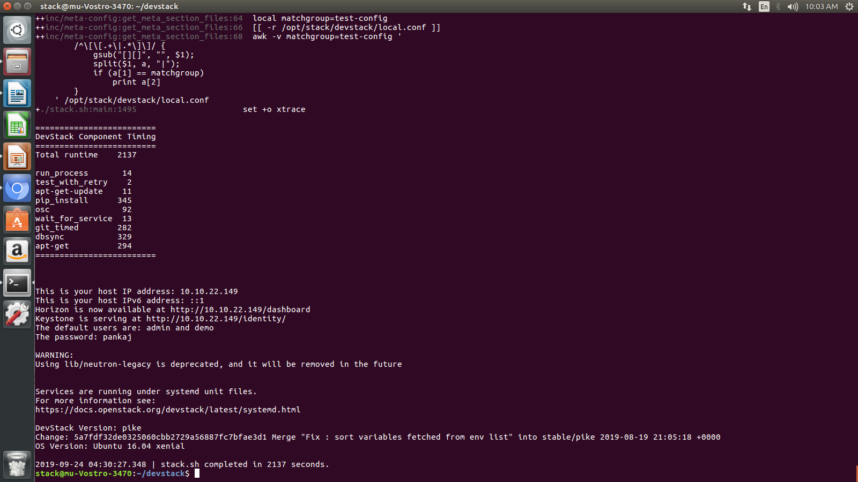
Step 12. To open Dashboard use the following command
http://10.10.22.149/dashboard
Uname - admin
Pass - your set password

